ASCE Conference Proceedings Paper Formatting Instructions

I. M. Author¹ and Charles. O. Author²

¹Hard Knocks Laboratory, Department of Civil and Environmental Engineering, Research State University, P.O. Box 98765, City, ST 99999-1111; PH (666) 911-1234; FAX (666) 911-1235; email: imauthor@esu.edu
²Everlasting Company, Mail Stop LC 444, 2233 West 32nd Avenue, Township, ST 88888; PH (999) 777-6666; FAX (999) 777-6667; email: co.author@everco.com

ABSTRACT
A proceedings containing papers presented at this conference will be produced from the manuscripts received from authors. These instructions are formatted to resemble a final paper. Your abstract should be about 150 words long; it must never exceed the first page or contain artwork or references. The abstract should present a concise statement of the scope, principal findings, and conclusions of the paper.

SUBMISSION DEADLINE AND PAPER LENGTH

Specifically for the 2016 ASCE Earth and Space Conference, the paper length is 6-pages minimum up to 12-pages suggested. A 15-page maximum can be accommodated with additional of $20/page required for pages 13-15 (collected with your registration submission). Timeline and procedure for submission of full paper and any other updates will be posted on the conference website (http://earthspaceconf.mst.edu).

Special Note
ASCE does not publish abstract only submissions or PowerPoint presentations in conference proceedings.

COPYRIGHT TRANSFER

No paper can be included in an ASCE publication unless the author has agreed to the terms in the ASCE Authorship Originality and Copyright Transfer Agreement. (See Copyright Basics for more information on ASCE’s copyright requirements, an explanation of what authors can do with their own material, and sponsored access options.)

FORMAT

Language and Presentation. Official language used during conference is English. All papers must be prepared and presented in English. Papers that are not presented at conference will be removed from the conference proceedings.

Length. Paper length as determined by the conference technical chair includes all text, graphics, and appendices. Please limit abstract to first page of paper.

Point size and font. Use 12 point type for text, captions, and author contact information. For type within figures or tables, the 12 point size is preferred. We recommend selecting a serif text font such as Times Roman. Italics, bold, and bold italics may be used; we recommend sticking to one “family” of typefaces. Try to avoid the use of Arial fonts as these can be distorted in the conversion to pdf.

Layout. All text must be single-spaced. Page design should be consistent throughout the paper.

Margin settings (see Table 1) must contain all elements of the paper that will be reproduced (text, figures, tables, captions). Imagine a “box” whose width does not exceed 5.75 in. (146 mm) and depth does not exceed 9 in. (229 mm). Short pages are unsightly and waste space; try to fill the imaginary box on each page. See Table 1 for suggested margin settings.

Table 1. Margin Settings.
Margins | Letter (8.5 x 11 in.) | A4 (210 x 297 mm)
Top, first page only | 1.50 in. | 51 mm
Top | 1.00 in. | 34 mm
Bottom | 1.00 in. | 34 mm
Left | 1.38 in. | 32 mm
Right | 1.38 in. | 32 mm

Figures and tables. All graphics (photos, line art, and tables) must fit within the above margin settings. All graphics should be understandable when printed in black and white. Do not use only color as a distinguishing feature. Use symbols or patterns on line and bar graphs to identify lines and columns. Landscape orientation is acceptable.

Illustrations should be numbered consecutively as they are presented (Figure 1, Figure 2, etc., and Table 1, Table 2, etc.). Each figure should be mentioned or called out before it appears. More than one figure may appear on a page.

Captions and legends. A descriptive caption, including figure number, should be placed directly below the illustration (see Figure 1). A descriptive legend, including table number, should be placed immediately above the table (see Table 1).

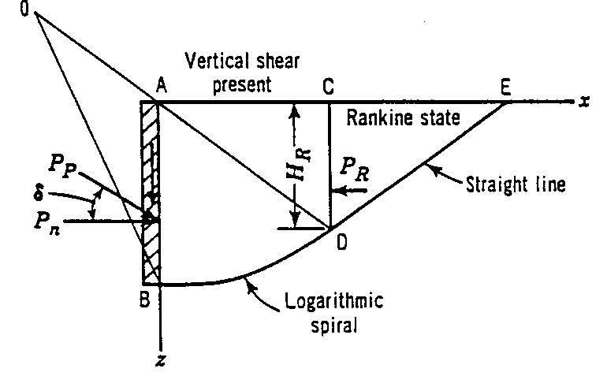
Figure 1. Sample line art illustration.

Style. The paper must be written in the best possible technical and grammatical English. Titles should be concise and should describe the content of the paper. If you have a long title, please consider a Title: Subtitle format.

Mathematics. All mathematics must be embedded in the text. Equations need to be numbered only if they are referred to more than once.

System of units. For more information about SI units, visit the websites of the U.S. Metric Association (USMA) or the National Institute of Standards and Technology (NIST) or consult the book, Metric Units in Engineering: Going SI (ASCE Press).

Author contact information. A sample of author contact information is shown on the first page of these instructions. The following information may be provided for all authors of the paper: author’s full name; Society membership grade; academic degrees or honorifics; current employment affiliation; postal and electronic mailing addresses; phone and fax numbers.

References. All references should appear together at the end of the paper (see below). References are listed alphabetically by last name of the first author. When two or more references by the same author are listed, year of publication is taken into account, and the earliest work is listed first. Wherever reference is made in the text to an author’s work, the author’s last name(s) and year of publication should appear in parentheses, e.g. ASCE (2014), Burka (1993), Zhou and Attard (2014), and Dhillon et al (2013). We strongly recommend that superscripts not be used to denote references, as these numbers often appear too small to be read easily. All listed references must be cited in text. (See samples below; see also Author-Date References for detailed guidance.)

PERMISSIONS

If a figure, photograph, or table has been published previously, the author must obtain written approval from the original publisher. (See Permissions Basics for detailed information.)

APPROVALS

It is the author’s responsibility to obtain all necessary approvals from the author’s employer prior to submission of the paper. Once a paper has been uploaded, reviewed by the author, and officially submitted, it is not possible to edit the document.

CONCLUSION

With thanks for your efforts, we look forward to providing a record of this conference that will be useful to you and your colleagues for many years to come.

REFERENCES

ASCE (2014). Minimum Design Loads for Buildings and Other Structures, Standard ASCE/SEI 7-10. Third printing. American Society of Civil Engineers (ASCE), Reston, VA.
Burka, L. P. (1993). “A hypertext history of multi-user dimensions.” MUD history, <http://www.ccs.neu.edu> (Dec. 5, 2013).
Committee on Curtain Wall Systems (2014). Curtain Wall Systems: A Primer, ASCE Manuals and Reports on Engineering Practice No. 126. Memari, Ali M., ed. ASCE, Reston, VA.
Dhillon, G. S., Surinder K., Ajila C.M., Brar, S. K., Verma, M., Tyagi, R.D., and Surampalli, R. Y. (2013). “Greenhouse Gas Contribution on Climate Change.” Chapter 3 in Climate Change Modeling, Mitigation, and Adaptation, Rao Y. Surampalli, Tian C. Zhang, C.S.P. Ojha, B. Gurjar, R.D. Tyagi, and S.M. Kao, eds. ASCE, Reston, VA, 26-61.
Garrett, D. L. (2003). “Coupled analysis of floating production systems.” Proc., Int. Symp. on Deep Mooring Systems, ASCE, Reston, VA, 152-167.
Singh, V. P. (2014). Entropy Theory in Hydraulic Engineering: An Introduction. ASCE Press. ASCE, Reston, VA.
Stahl, D. C., Wolfe, R. W., and Begel, M. (2004). “Improved analysis of timber rivet connections.” J. Struct. Eng., 130(8), 1272-1279.
Zhou, H. and Attard, T. (2014). "Simplified Anisotropic Plasticity Model for Analyzing the Postyield Behavior of Cold-Formed Sheet-Metal Shear Panel Structures." J. Struct. Eng. , 10.1061/(ASCE)ST.1943-541X.0001152, 04014185.

